**Roles:**

**Creating an ansible role:**

* **ansible-galaxy init role_name**

with this command, a role will be created in “/etc/ansible/roles” directory with the given name. inside that, there will be multiple directories created.

**Structure of roles:**

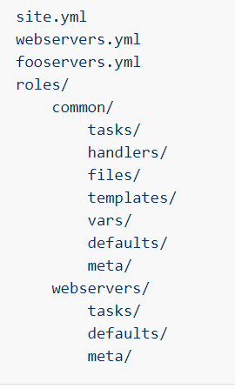

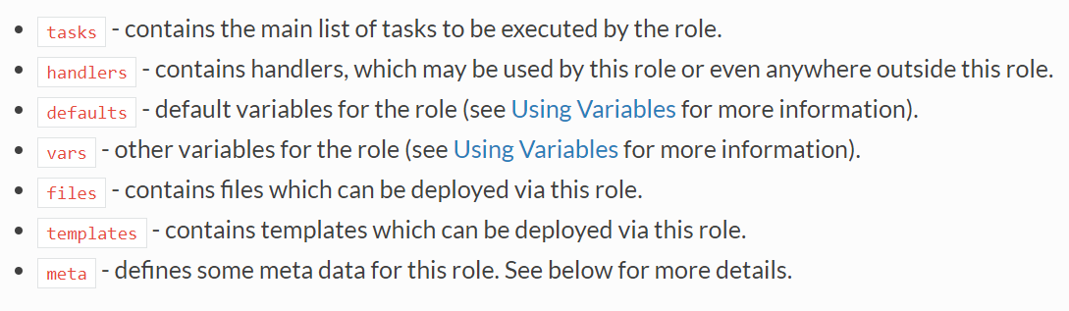

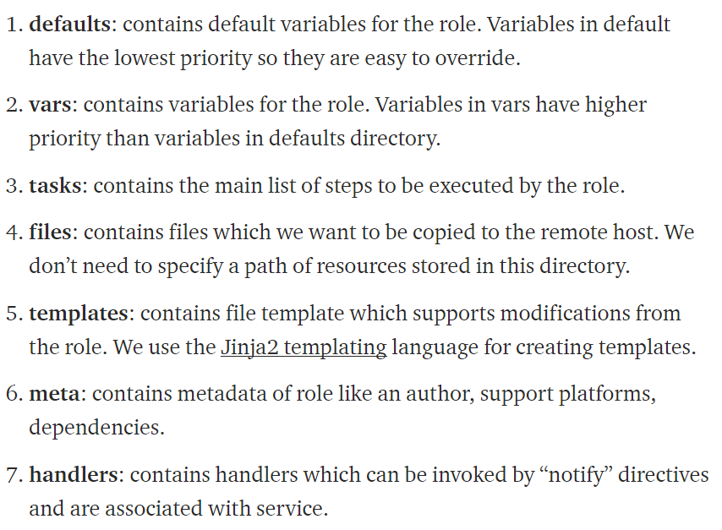

* Common folder contains all the subfolders which are common for all the tasks.
* We can create separate roles also based on our requirement and place the files inside sub directories with “main.yml” as below.
* Under roles, if we have tasks, we need to write inside main.yml under tasks folder, if we have handlers, we need to write inside main.yml under handlers’ folder

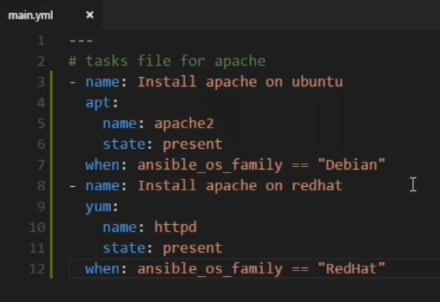

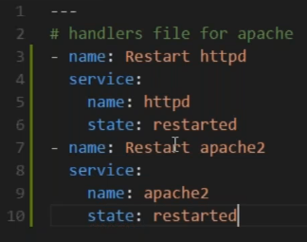

* Inside tasks, if we want, me can break down the tasks in to multiple yaml files and import them all inside main.yml as below

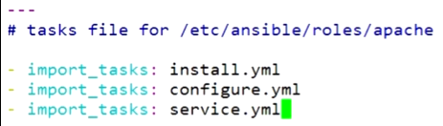

**Using roles:**

* We can create a yaml file and add the required roles

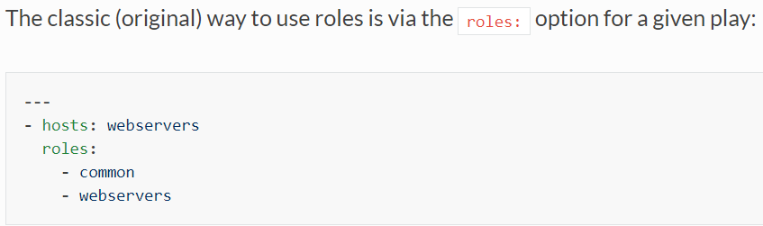

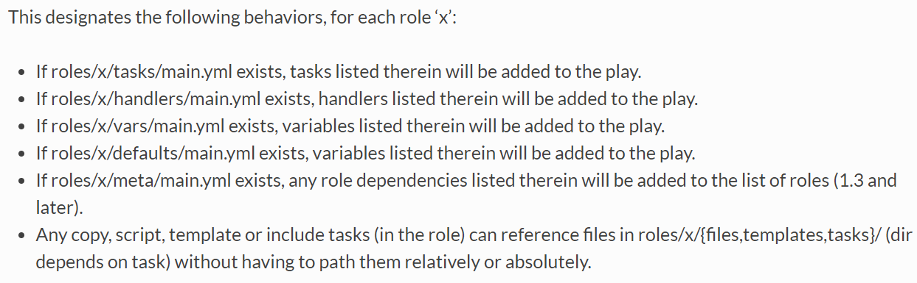

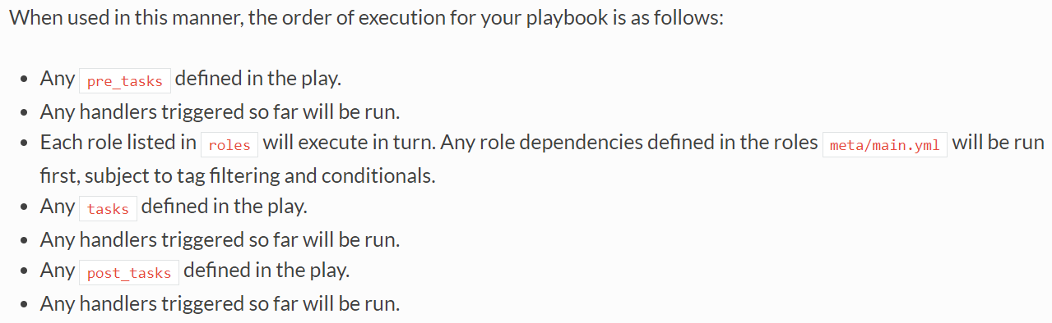

**Import/include role:**

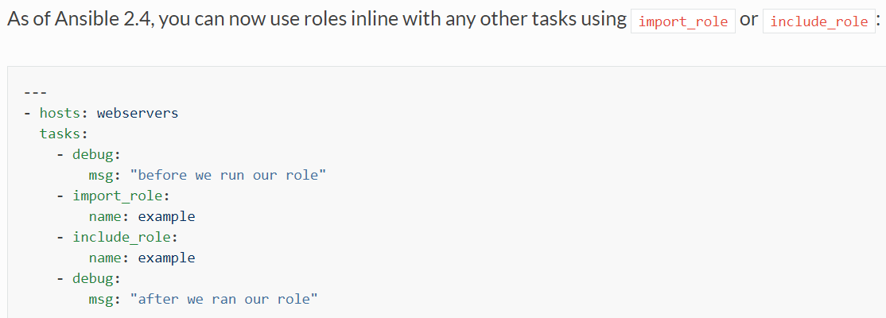

**Role with fully qualified path:**

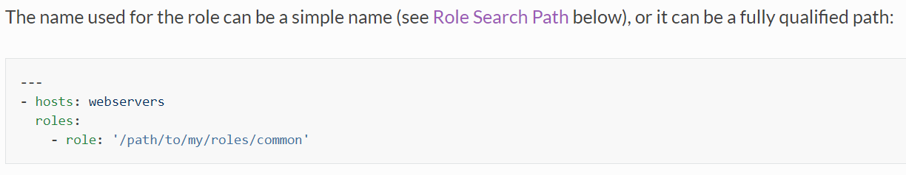

**Roles with variables:**

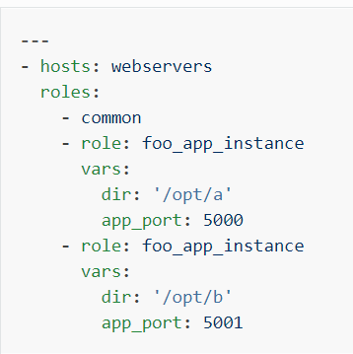

**Roles with condition:**

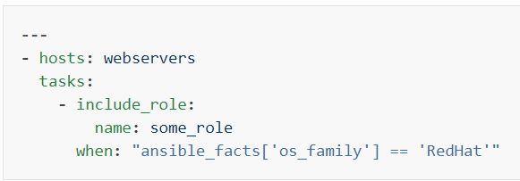

**Import roles with tags:**

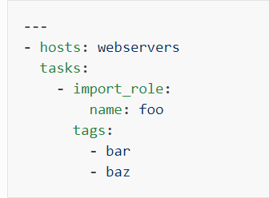

**Ansible galaxy:**

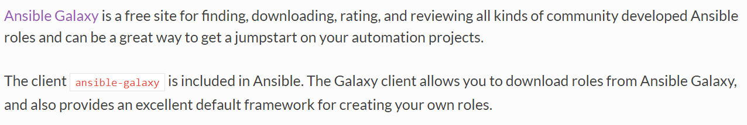

**Meta file:**

* If our roles are in different locations other than usual location, it gives an error
* So, to solve that issue, we use meta here. Write the dependencies inside the main.xml under meta folder
* Even if it is not present, it will download it

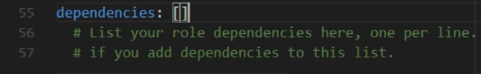

* This is how we write it. It will download automatically if the role is in galaxy

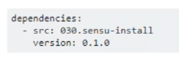

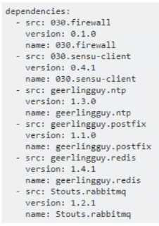

* It is better to check the versions etc mentioned in galaxy roles and download it
* If the roles are not present in galaxy site, we can use http in site.yml to download from other sites like github etc.
* It is better always writing yml file first and split that into roles
* If we have written a playbook which has 10 steps, out of that if we want to execute only 2 steps then there is a concept called tags
* It is older way of using, not many people use it

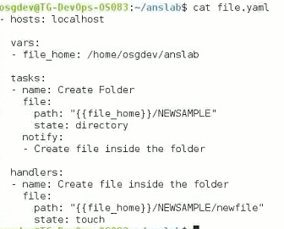

* We can create yml files other than main.yml like install.yml, service.yml etc. but we need to include all of them in main.yml